Patrick Conley
Dr. Ju Shen
CPS 356 - Operating Systems
Project 1 Report
For this project, matrix multiplication was performed in Java both using threads and not using threads. In Java, when a thread is created, it maps one-to-one to the thread in the operating system, making the use of threads more efficient than not using threads on processes that can happen in parallel. For matrix multiplication, the multiplication between rows of the first matrix and columns of the second matrix can be done in parallel, so using threads should speed up the process, especially for larger matrices being multiplied together.

The following things were tested by the main function in Matrix.java:
- That simple matrix multiplication on smaller matrices would produce the same results using the multiplyBy() (without threads) and multiplyByThreads() (with threads). In the code, the results were the same no matter what function was used.
- Next, two larger matrices were multiplied by one another. A 1000 x 2000 was multiplied with a 2000 x 1000, and as predicted, the multiplication using multiplyByThreads() was much faster.
- The code then printed out the results of the comparison and established that multiplication using threads was indeed more efficient. (more than 3 times faster on average for large matrices).

Sample Output shown on next page
Sample Output:
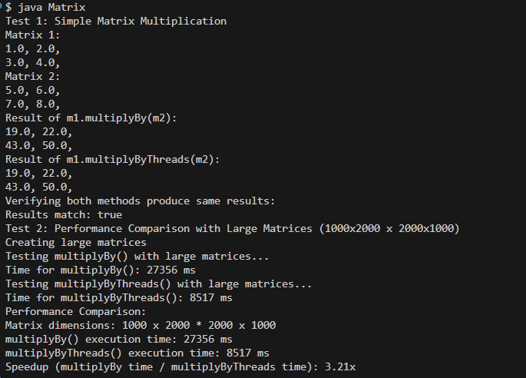

Results and Analysis:
As predicted, performing matrix multiplication with threads was faster than without threads. Matrix multiplication can be performed in parallel, independent steps that happen at the same time to speed up the process of multiplying them together. This idea is important because pixels are stored on a screen in matrices, so in different environments where pictures or videos are displayed, efficient matrix multiplication is important to ensure good picture/video quality and to avoid buffer delays.

